**CBT Worksheet for Kids: The Thought Garden - Growing Happy Thoughts**

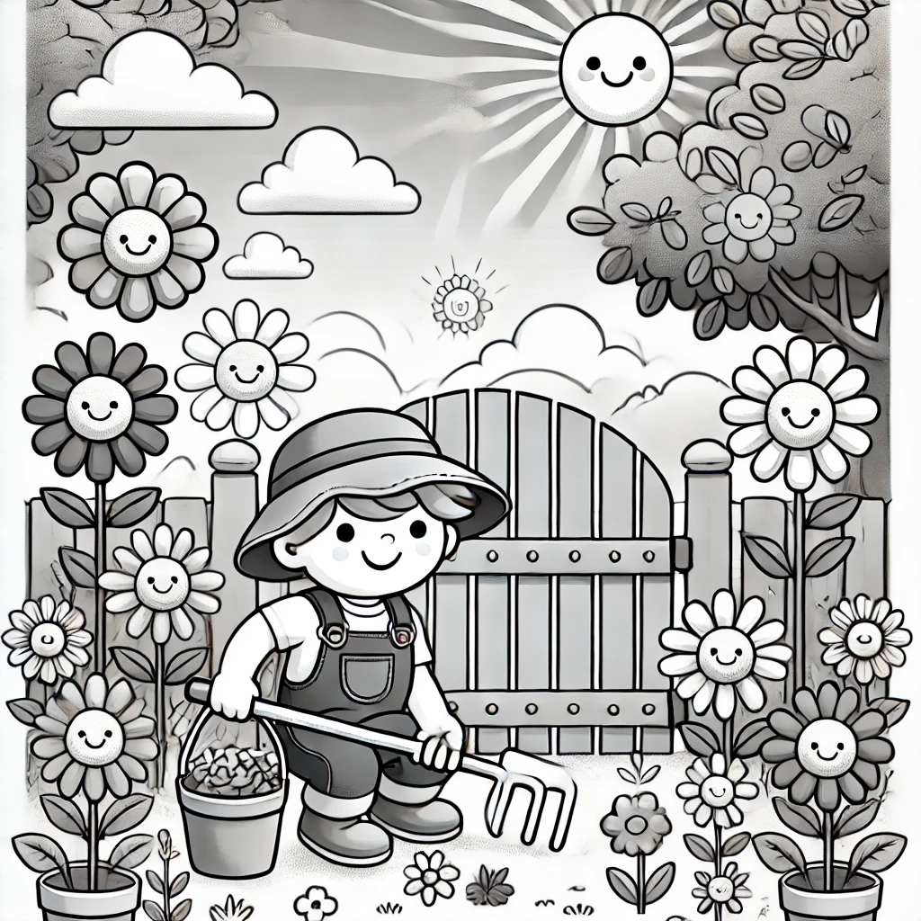

**Purpose:**

In this worksheet, you are going to be the gardener of your own mind. Just like a garden needs care, your thoughts need care too. Some thoughts can be like weeds that make you feel bad, and some are like beautiful flowers that help you feel good. In this activity, you’ll learn how to get rid of the bad thoughts (weeds) and grow good thoughts (flowers). This will help you take care of your mind and feel better!

**Instructions:**

1. **The Garden Gate: What Happened?**  
   Every garden starts with a space to grow. In your mind, there is a place where your thoughts grow. Something happened that made you upset. What happened? Write down what happened below.

**What happened that made you feel upset?**  
*Example: “I lost my favorite toy.”*

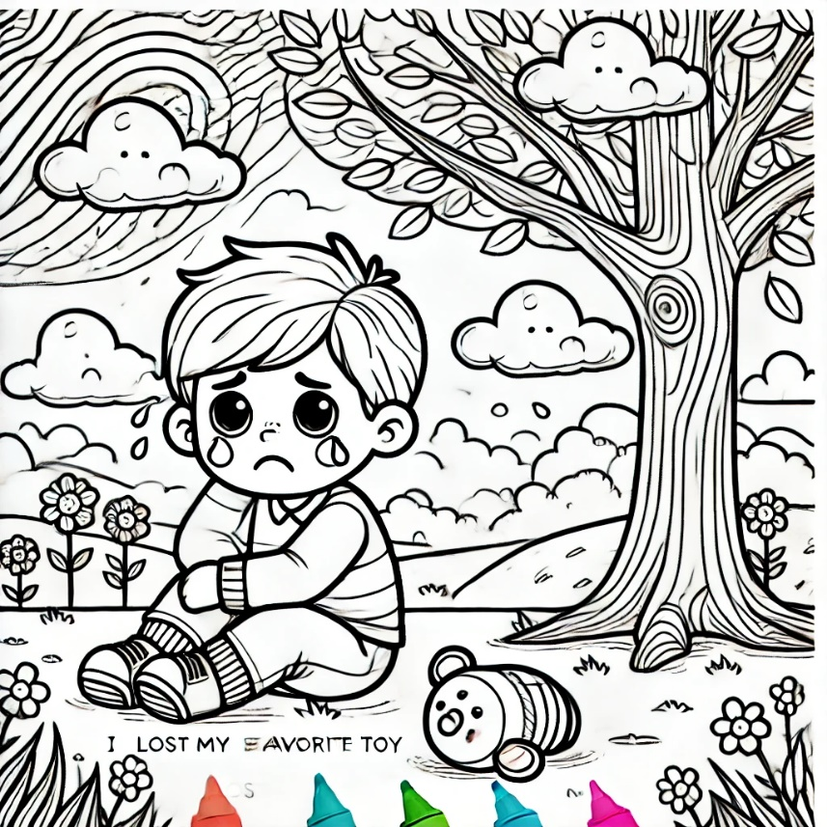

1. **Weeds in the Garden: What Was the Thought?**  
   Sometimes, our thoughts can be like weeds in a garden—they grow fast and make us feel bad. What thought popped into your head when you got upset? Write it down like you’re picking a weed out of your garden.

**What thought made you upset?**  
*Example: “I’ll never find my toy again.”*

1. **Is This Thought True?**  
   Every weed has roots. To keep your garden healthy, you need to check if the weed is really true. Is your thought really true, or is it just something that’s making you feel bad?

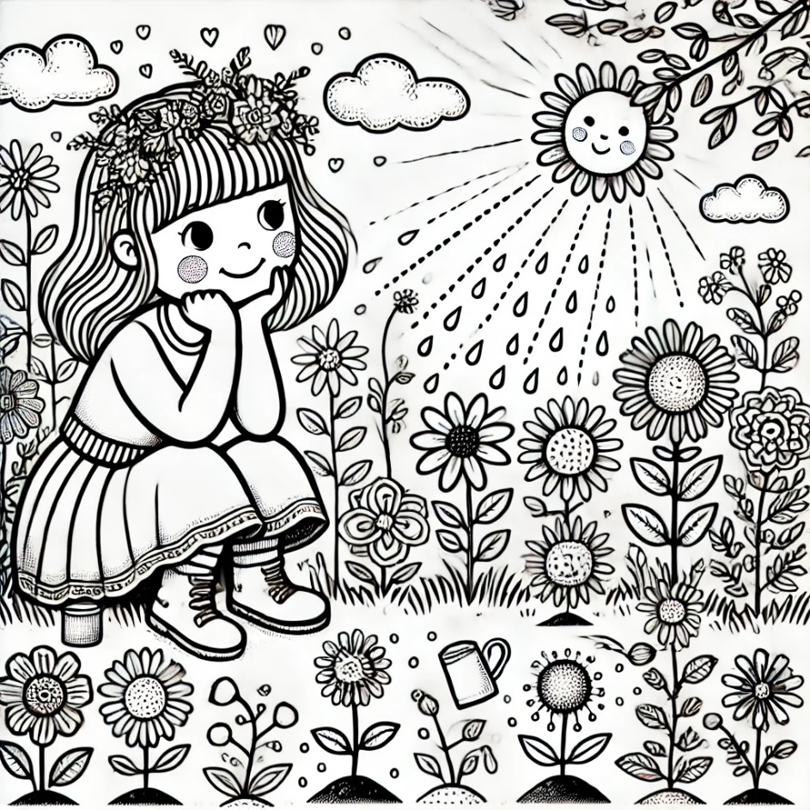

**What’s the evidence that your thought is true?**  
*Example: “I lost it and can’t find it anywhere.”*

**What’s the evidence that your thought might NOT be true?**  
*Example: “I’ve lost things before and always found them later.”*

1. **Planting New Seeds: What’s a Helpful Thought?**  
   Now, let’s plant some new seeds in your garden. These are thoughts that help you feel better! If your thought was like a weed, what’s a new thought you can plant that will make you feel good? This is like planting a beautiful flower in your garden.

**What’s a new, helpful thought you can have?**  
*Example: “Maybe my toy will show up if I keep looking carefully.”*

1. **Watering the Garden: How Does This New Thought Make You Feel?**  
   After you plant a seed, you need to water it to help it grow. How does this new thought make you feel? Does it make you feel better or calmer?

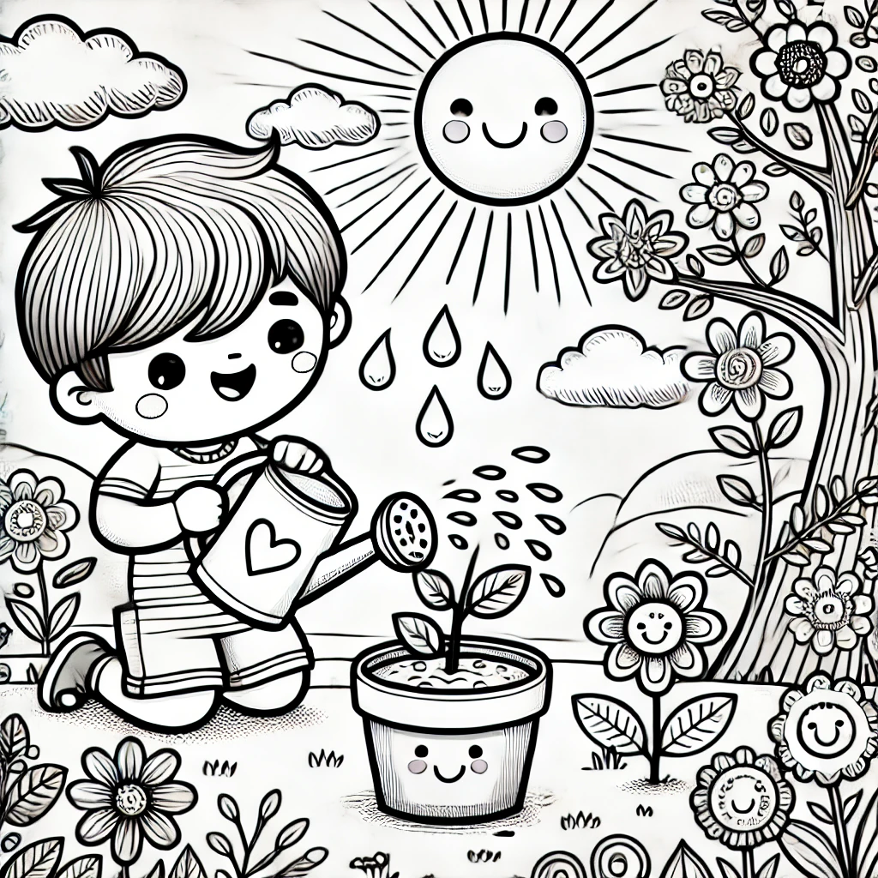

**How do you feel now after changing your thought?**  
*Example: “I feel hopeful and not as upset.”*

1. **Taking Care of Your Garden: What Will You Do Next Time?**  
   To keep your garden healthy, you need to care for it every day. Next time something happens that makes you upset, what will you do? You can pull out the weeds and plant flowers again!

**What will you do next time you feel upset?**  
*Example: “Next time, I’ll think of a good thought and take a deep breath.”*

1. **Garden Check-In**  
   Every week, check on your garden and see how it’s growing. Is it full of flowers, or do you need to pull some weeds and plant new seeds? Keep looking after your thoughts, and they’ll grow stronger and happier!

**How is your Thought Garden today? Are there more flowers than weeds?**  
*Example: “Today, I feel better because I replaced my bad thoughts with good ones.”*

**Conclusion:**

Great job! You’ve done a wonderful job taking care of your Thought Garden. The more you practice, the stronger your garden will grow, full of happy thoughts. Every time you notice a weed (a bad thought), you can pull it out and plant a new, helpful thought in its place. Keep watering your garden and watch it grow into something amazing!

