The Emotion Compass
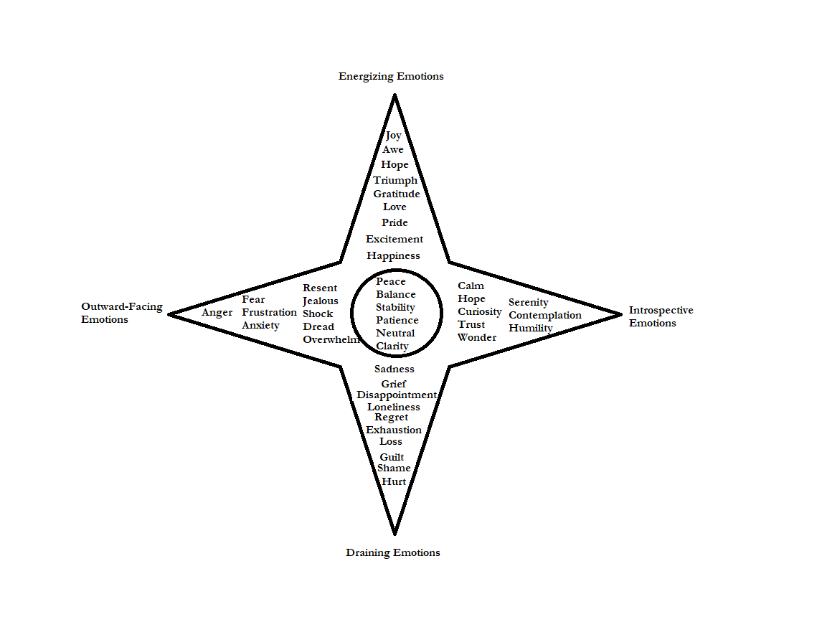

The Emotion Compass is a gentle guide to help you explore and understand the landscape of your emotions. Each direction—North, South, East, and West—represents a unique aspect of emotional experience, from the uplifting light of joy and gratitude to the reflective calm of peace and curiosity, the heaviness of sadness and regret, and the outward intensity of anger and frustration. At the center lies the stillness of balance and clarity, where you can align your emotions with purpose and find inner peace. As you navigate the compass, you’ll uncover deeper insights, recognize patterns, and embrace the grace needed to journey through life’s emotional seasons with hope and strength.
Understanding the definitions of emotions is a vital step in personal growth, as it allows you to name and navigate your feelings with clarity and purpose. When you can identify what you're experiencing, you gain the power to respond intentionally rather than react impulsively. Each emotion carries valuable insight into your needs, boundaries, and desires, guiding you toward deeper self-awareness and healthier relationships. By exploring the meaning and role of your emotions, you open the door to greater emotional resilience and balance in your life.
Activity:
Reflect on a recent emotional experience that stood out to you—whether it was positive or challenging. Write down the emotion you felt and its definition from the list. Then ask yourself: What triggered this feeling? What was it trying to tell me about my needs or values? Use this reflection to better understand your emotional patterns and how they shape your journey.
Definitions:
North: Positive, Energizing Emotions
Joy: A feeling of great happiness or delight. Example: Laughing with friends at a surprise party.
Awe: A deep admiration or wonder, often in response to something vast or beautiful. Example: Standing at the edge of a breathtaking canyon.
Hope: A belief that good things are possible or that a challenging situation can improve. Example: Looking forward to starting a new job after a tough period.
Triumph: A sense of victory or accomplishment after overcoming a challenge. Example: Finishing a marathon after months of training.
Gratitude: A warm appreciation for what one has or receives. Example: Feeling thankful for a supportive family.
Love: A deep affection and care for someone or something. Example: Watching your child achieve something they’ve worked hard for.
Pride: A sense of satisfaction or accomplishment in oneself or others. Example: Completing a difficult project successfully.
Excitement: A feeling of enthusiasm and eagerness for something positive. Example: Anticipating a vacation to a dream destination.
Happiness: A general sense of contentment or pleasure. Example: Enjoying a sunny day at the park.
East: Reflective, Introspective Emotions
Calm: A state of peace and tranquility, free from agitation or worry. Example: Sitting by a quiet lake early in the morning.
Hope: The gentle belief in the possibility of a positive outcome. Example: Believing a new treatment might help a loved one heal.
Curiosity: A desire to learn or explore something new. Example: Reading a book on a subject you’ve always wanted to know about.
Trust: A feeling of confidence or reliance in someone or something. Example: Sharing a personal secret with a close friend.
Wonder: A sense of amazement and fascination with the world or an experience. Example: Watching a meteor shower for the first time.
Serenity: A state of deep peace and untroubled calmness. Example: Relaxing in a warm bath after a stressful day.
Contemplation: Deep reflection or thoughtful consideration. Example: Thinking about the meaning of a life event during a quiet moment.
Humility: A recognition of one’s limitations or the value of others without arrogance. Example: Acknowledging the team’s effort in a group success rather than taking all the credit.
South: Negative, Draining Emotions
Sadness: A feeling of sorrow or unhappiness. Example: Missing a loved one who has moved away.
Grief: Deep sorrow, especially from loss. Example: Mourning the death of a beloved pet.
Disappointment: A feeling of dissatisfaction when expectations aren’t met. Example: Not getting a promotion you worked hard for.
Loneliness: A sense of isolation or being disconnected from others. Example: Feeling left out when friends go out without inviting you.
Regret: Wishing you had done something differently. Example: Feeling bad about saying something hurtful in anger.
Exhaustion: Extreme mental or physical fatigue. Example: Feeling completely drained after working long hours without rest.
Loss: The feeling of missing something or someone important. Example: Moving away from a place that felt like home.
Guilt: Feeling responsible for a wrongdoing or mistake. Example: Forgetting an important event for a friend.
Shame: A painful feeling of embarrassment or unworthiness. Example: Feeling ashamed after failing a task you believed you were good at.
Hurt: Emotional pain caused by someone or something. Example: Feeling hurt by a friend’s unkind remark.
West: Reactive, Outward-Facing Emotions
Anger: A strong feeling of displeasure or frustration. Example: Becoming upset when treated unfairly.
Fear: An emotional response to a perceived threat or danger. Example: Feeling scared when hearing unexpected noises at night.
Frustration: Irritation caused by obstacles or unmet needs. Example: Waiting in a long line when you’re in a hurry.
Anxiety: A feeling of worry or unease about the future. Example: Nervousness before giving an important presentation.
Resentment: Lingering bitterness toward someone for a perceived wrong. Example: Feeling resentful toward a coworker who took credit for your idea.
Jealousy: A feeling of envy toward someone else’s advantages. Example: Wishing you had the same success as a colleague.
Shock: A sudden feeling of surprise or disbelief. Example: Hearing unexpected bad news.
Dread: Anticipating something unpleasant with fear or anxiety. Example: Feeling dread before a difficult conversation.
Overwhelm: Being overcome with too many emotions or responsibilities. Example: Struggling to manage a packed schedule.
Center: Emotional Balance
Peace: A state of calm and freedom from disturbance. Example: Meditating quietly after a busy day.
Balance: A sense of stability and control over emotions and responsibilities. Example: Feeling in control of work-life priorities.
Stability: A consistent state of steadiness or predictability. Example: Settling into a routine that supports your well-being.
Patience: The ability to remain calm and wait without frustration. Example: Waiting for someone to finish speaking before responding.
Neutral: An absence of strong positive or negative emotions. Example: Feeling neither happy nor sad while doing daily chores.
Clarity: A clear understanding or focus. Example: Knowing exactly what decision you want to make after reflection.

Reasoning For the Center
At the center of the Emotion Compass lies emotional balance—a place of clarity, peace, and stability. This central point represents the ability to process and integrate your emotions without being overwhelmed or detached. While the compass’s directions highlight the spectrum of emotional experiences, the center offers a grounding space where you can pause, reflect, and respond intentionally. Balance doesn’t mean the absence of emotions but rather the ability to navigate them with mindfulness and control. It’s where you align with your core values, find your footing, and connect with a sense of inner calm even amid emotional storms.
The center is crucial because it acts as a stabilizing force, linking all the directions together. Emotions like anger, sadness, joy, and curiosity are natural and necessary parts of life, but they can feel overwhelming when they dominate your perspective. By returning to the center, you create a foundation to explore these emotions without losing yourself in them. It’s from this grounded space that you can look to the North for energy and inspiration, to the South for understanding and healing, to the East for reflection and growth, and to the West for action and change. The center reminds us that while emotions are valuable guides, they don’t define us—we can choose how to engage with them to live with intention and purpose.

